Right, checking Azure Service Health; this is actually a combination of 3 different tools in one:

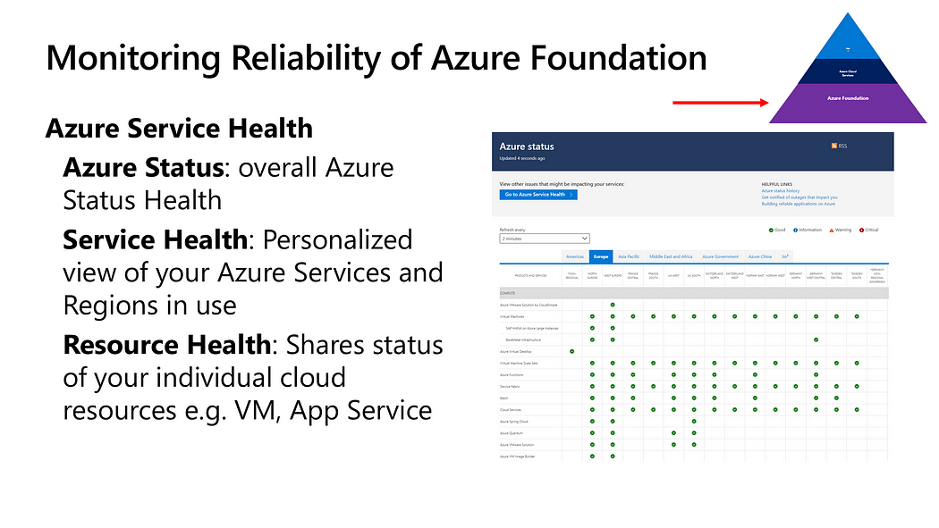

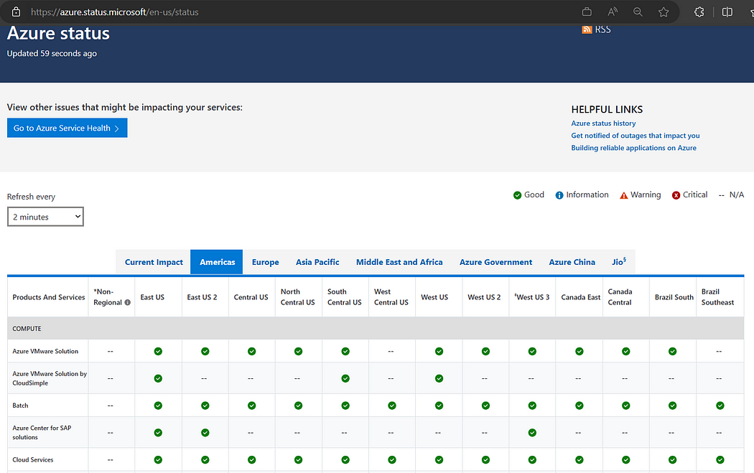

**Azure Status**: overall Azure Status Health

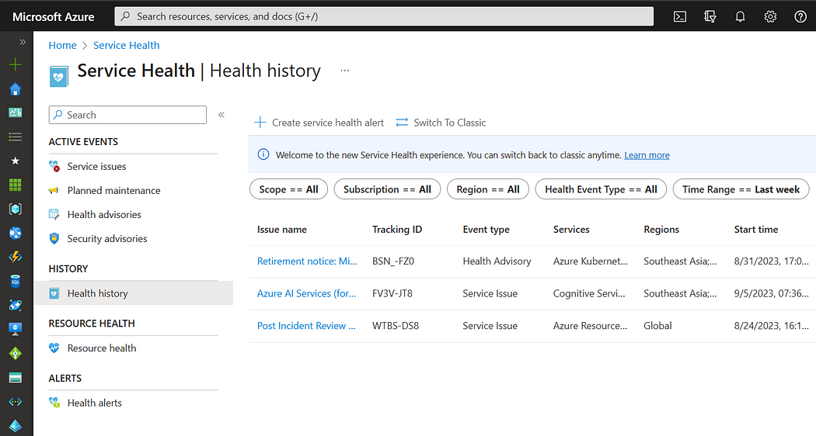

**Service Health**: Personalized view of your Azure Services and Regions in use

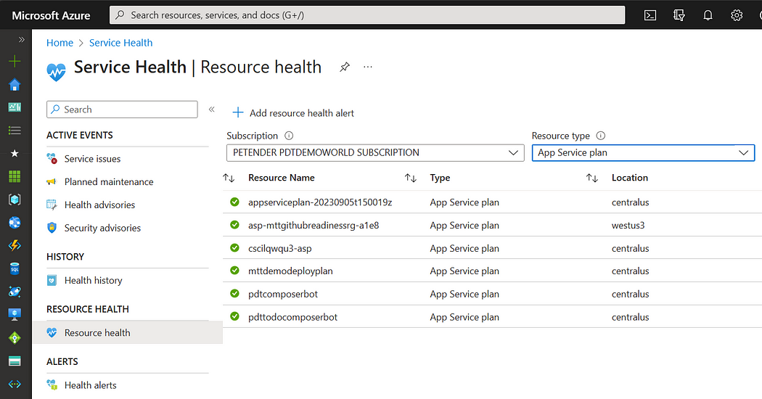

**Resource Health**: Shares status of your individual cloud resources e.g. VM, App Service

The **Azure Well Architected Framework** is a comprehensive guide provided by Microsoft to help architects build secure, high-performing, resilient, and efficient infrastructure for their applications. It aligns closely with SRE principles, as it emphasizes best practices for reliability and scalability.

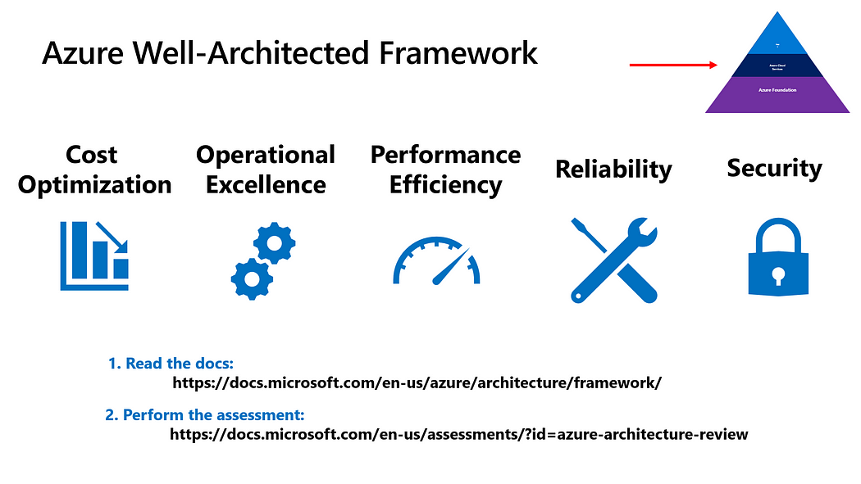

Here are some key elements of the Azure Well Architected Framework that contribute to SRE:

1. **Reliability Pillar**: This pillar of the framework specifically addresses the principles of SRE. It covers topics like fault tolerance, disaster recovery, and monitoring. Architects can use this guidance to design systems that meet their reliability SLOs.
2. **Operational Excellence Pillar**: SREs focus on automation and efficient operations. Azure’s Operational Excellence Pillar provides guidance on automating tasks, reducing manual intervention, and improving operational efficiency.
3. **Performance Efficiency Pillar**: Meeting SLOs often requires optimizing performance. This pillar offers insights into selecting the right Azure resources and configurations to achieve optimal performance for your workloads.
4. **Cost Optimization Pillar**: Managing costs is essential in SRE. Azure provides tools and best practices for cost management and optimization, helping teams stay within their error budgets.

Apart from these, I summarize a few other ***best practices*** if you want:

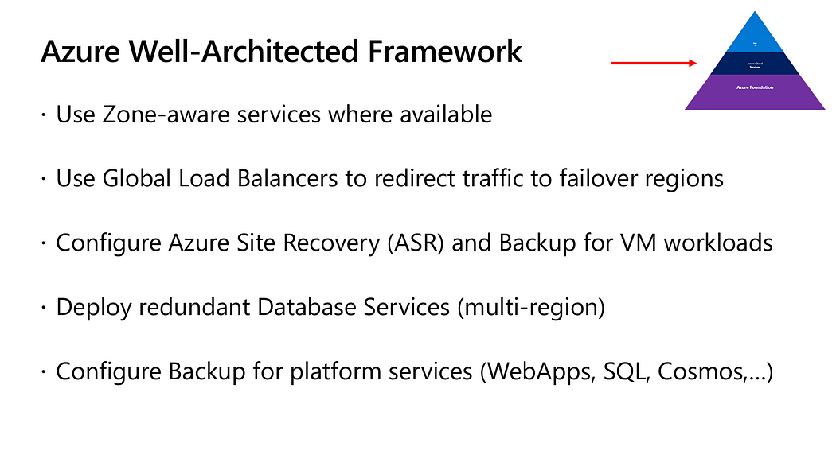

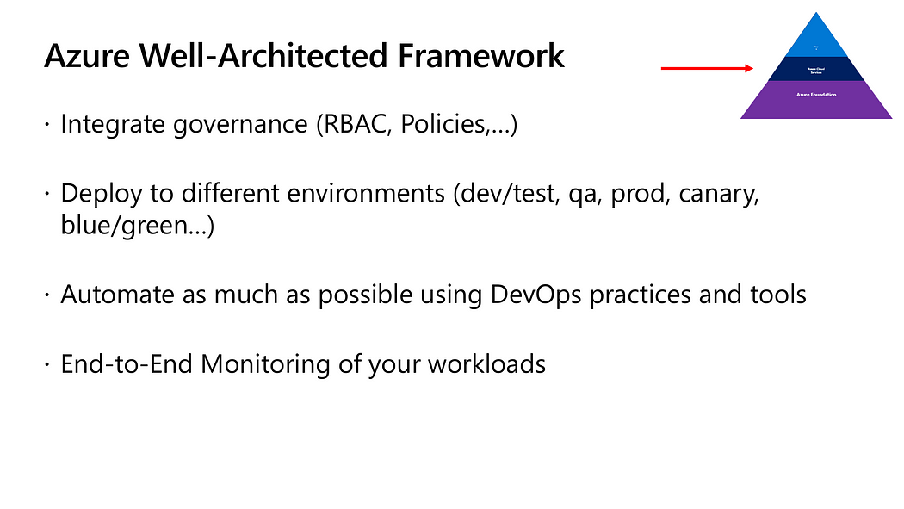

**Azure Service Level Agreements**

Service Level Agreements (SLAs) are a crucial aspect of SRE, as they define the expected reliability and availability of Azure services. Understanding Azure SLAs is essential for architects and SREs to design and operate reliable systems.

Key points about Azure SLAs:

1. **Availability Guarantees**: Azure SLAs typically guarantee high availability for services, such as Virtual Machines (VMs), Azure SQL Database, and Azure App Service. These SLAs specify the percentage of time a service is expected to be available.
2. **Service Credits**: Azure offers service credits if SLAs are not met. This financial compensation is part of Azure’s commitment to providing reliable services.
3. **Multi-Region Deployments**: To enhance reliability, architects can design their applications to span multiple Azure regions. This ensures redundancy and reduces the risk of downtime.
4. **Monitoring and Alerting**: Implementing effective monitoring and alerting systems is crucial to detect and respond to SLA violations promptly.

**Best Practices around DevOps in Regards to Azure Reliability**

DevOps practices play a pivotal role in achieving SRE goals. Integrating DevOps and SRE principles can lead to a culture of continuous improvement and reliability. Here are some best practices:

1. **Infrastructure as Code (IaC)**: Embrace IaC to automate the provisioning and configuration of Azure resources. Tools like Azure Resource Manager (ARM) templates and Terraform facilitate the management of infrastructure as code.
2. **Continuous Integration and Continuous Deployment (CI/CD)**: Implement CI/CD pipelines to automate software deployments. Azure DevOps Services, GitHub Actions, and Jenkins are popular tools for building robust CI/CD pipelines on Azure.
3. **Monitoring and Observability**: Utilize Azure Monitor, Application Insights, and Log Analytics to gain real-time visibility into your applications and infrastructure. This enables proactive issue detection and resolution.
4. **Automated Testing**: Implement automated testing practices, including unit tests, integration tests, and end-to-end tests. Azure DevTest Labs can help create test environments easily.
5. **Containerization and Orchestration**: Container technologies like Docker and Kubernetes can enhance application reliability and scalability. Azure Kubernetes Service (AKS) simplifies the management of Kubernetes clusters.
6. **Incident Management**: Define clear incident response procedures and automate incident detection and resolution where possible. Azure Service Health and Azure Logic Apps can be valuable here.

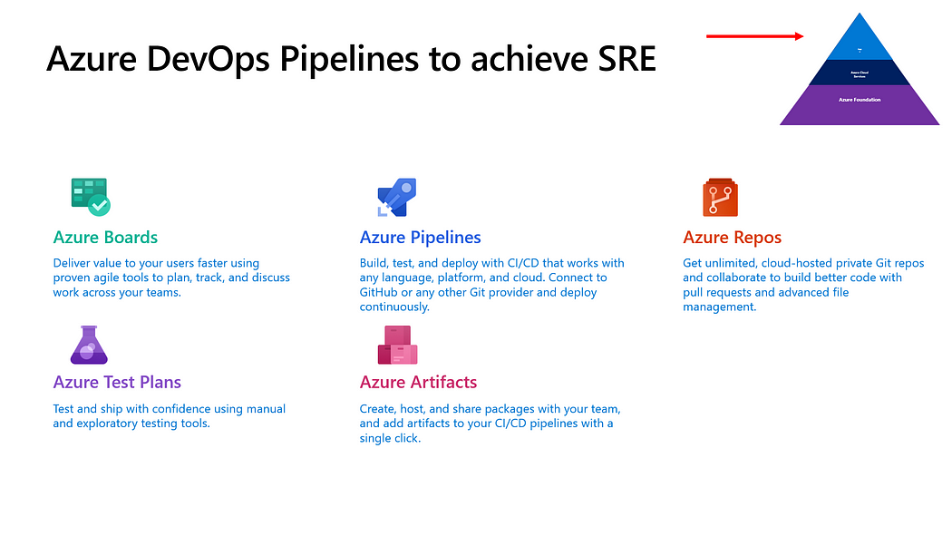

**Chaos Engineering and Azure Chaos Studio**

Chaos Engineering is a practice that involves deliberately injecting failures and faults into a system to test its resilience. Azure offers a powerful toolset, including **Azure Chaos Studio**, to help organizations practice Chaos Engineering and improve the reliability of their Azure-based applications.

Key components of Azure Chaos Studio:

1. **Experimentation**: Azure Chaos Studio allows you to create controlled experiments that simulate various failure scenarios, such as network disruptions, high CPU usage, or database outages.
2. **Observability**: Gain insights into how your system behaves under stress by collecting and analyzing telemetry data during chaos experiments. This data helps identify weaknesses and areas for improvement.
3. **Automation**: Automate the execution of chaos experiments to ensure consistency and repeatability. This is especially valuable for ongoing testing and validation of your system’s reliability.
4. **Integration with Azure Services**: Azure Chaos Studio integrates seamlessly with Azure services, making it easy to test the resilience of Azure-based applications and services.

(For more details on Chaos Engineering and Azure Chaos Studio, read [my recent blog post on the subject](https://www.007ffflearning.com/post/intro-to-chaos-engineering-and-azure-chaos-studio-preview/))

**Conclusion**

Achieving Site Reliability Engineering with Azure involves a combination of best practices, tools, and a strong focus on reliability. By following the Azure Well Architected Framework, understanding Azure SLAs, implementing DevOps best practices, and experimenting with Chaos Engineering using Azure Chaos Studio, organizations can build highly reliable and resilient systems on Microsoft’s cloud platform.

As Azure continues to evolve, it offers an ever-expanding set of tools and services that align with SRE principles. By staying informed about the latest Azure offerings and incorporating them into your SRE practices, you can ensure that your applications and services meet their reliability objectives in the dynamic world of cloud computing.